**ASSIGNMENT 4**

**Tables in 1st Normal Form (1NF):**

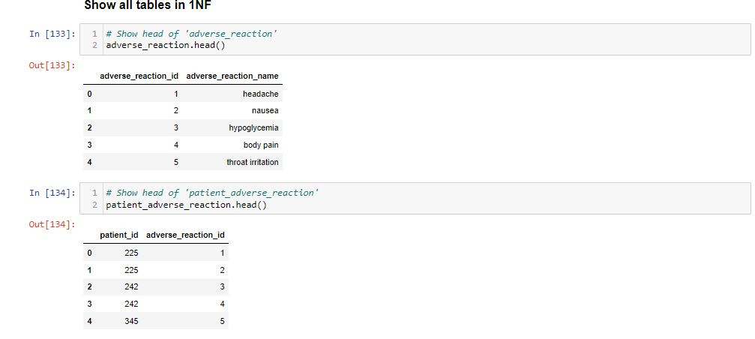

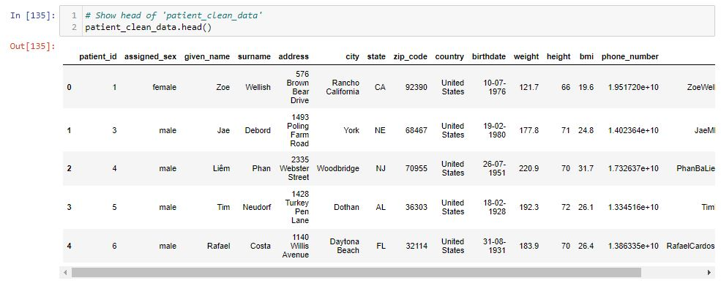

**Tables in 2nd Normal Form (2NF):**

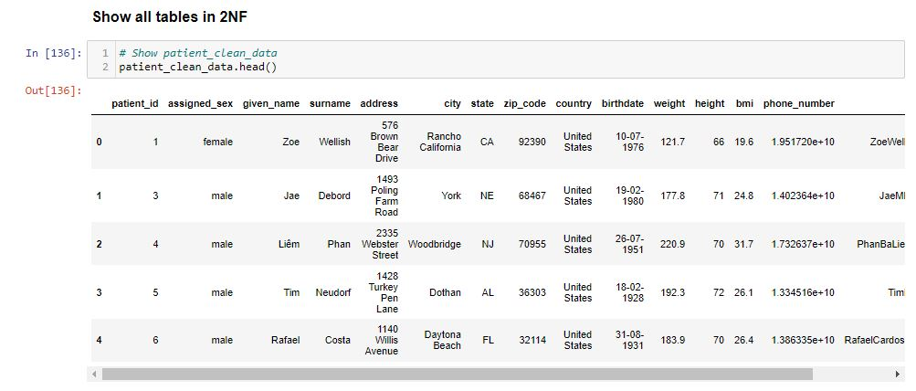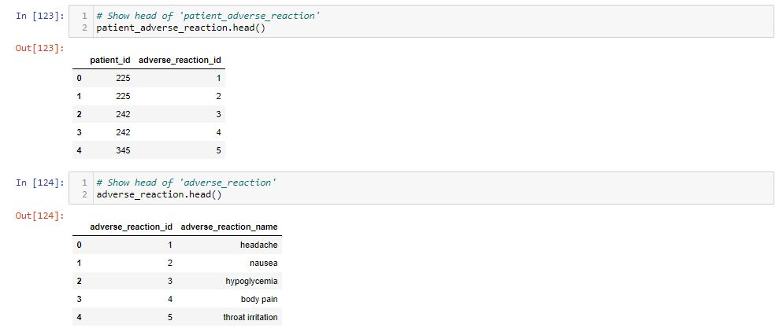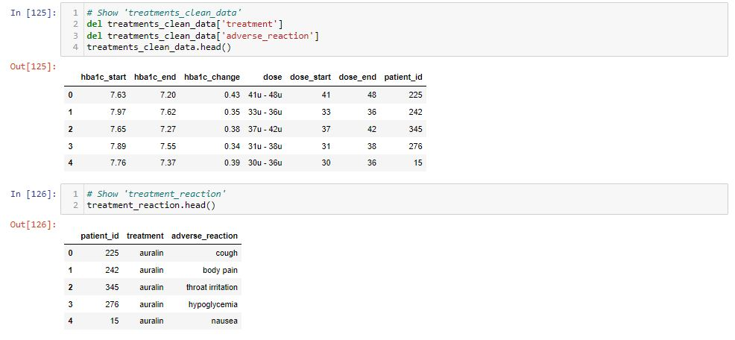

**Tables in 3rd Normal Form (3NF):**

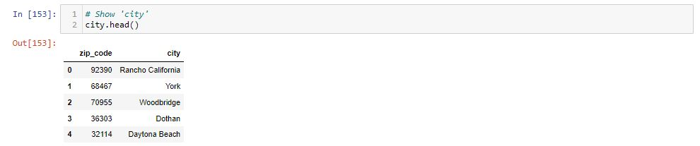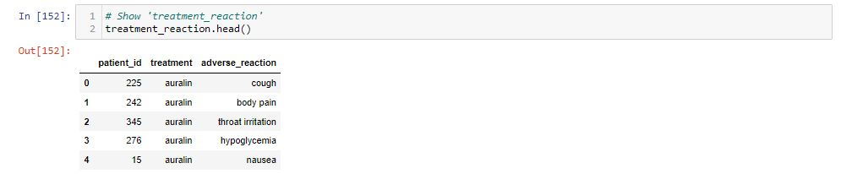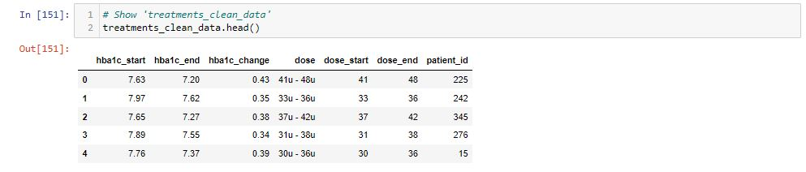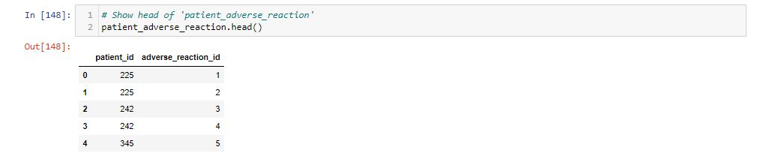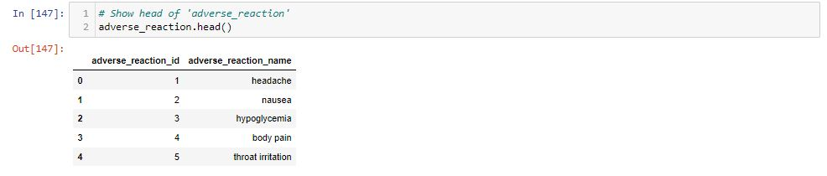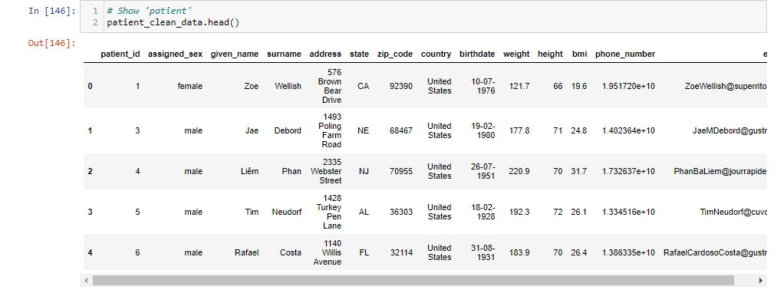

**View for all the use cases:**

**Which user posted this tweet?**

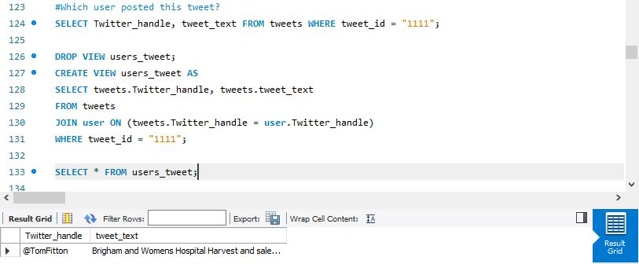

**When did the user post this tweet?**

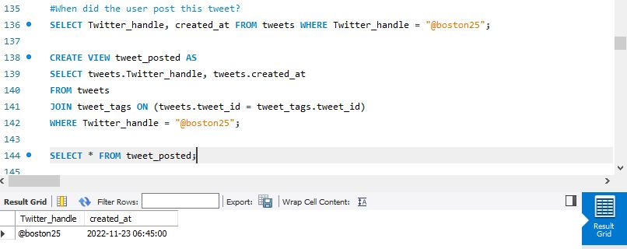

**What tweet has the user posted in last 24 hours?**

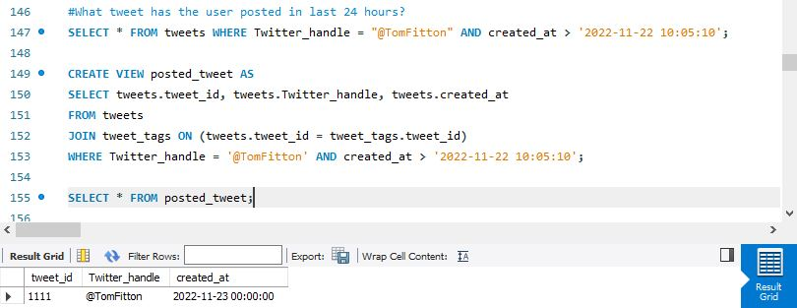

**How many users have followers more than 3 Million?**

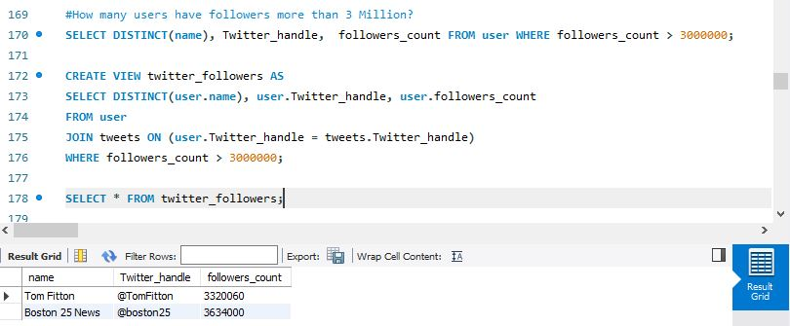

**Are there any users who mentioned about Womens Hospital?**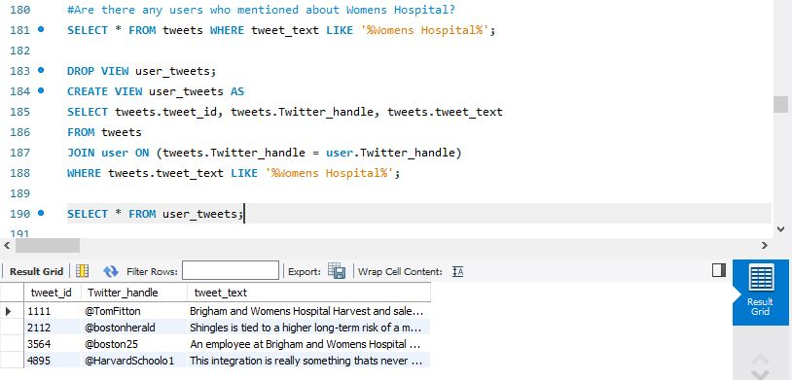

**Which doctor is a male dermat specialist?**

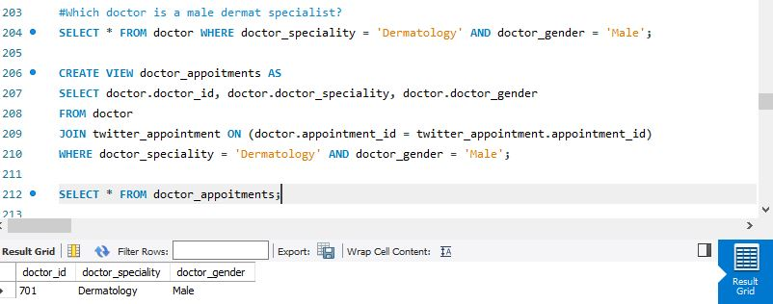

**Which appointments are booked in last 3 months?**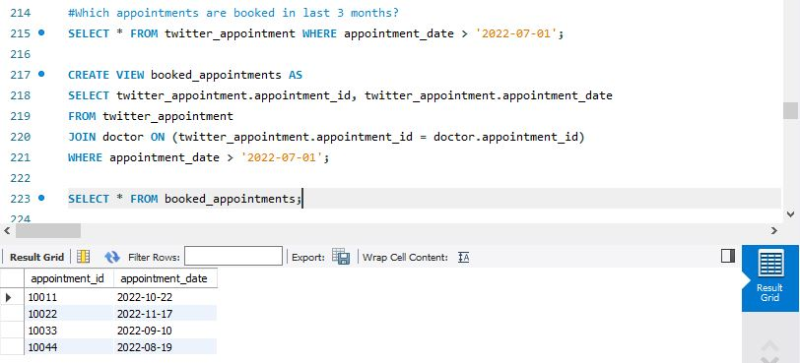

**How many different speciality doctors are present?**

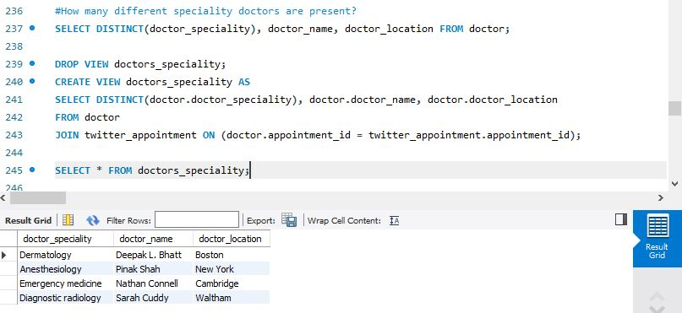

**How many Female doctors are there in the hospital?**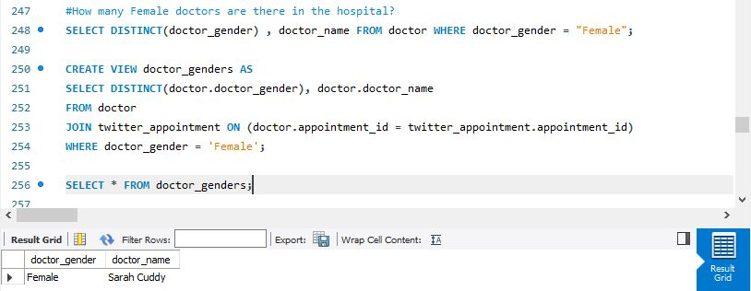

**How many Male patients are there?**

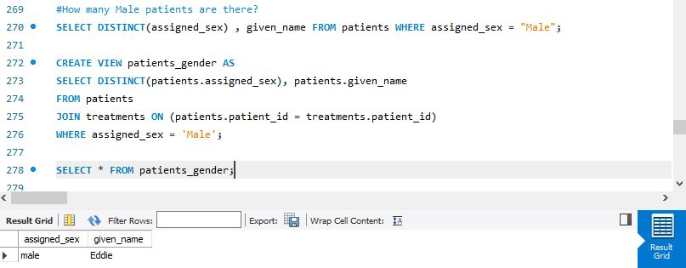

**How many patients have hypoglycemia as adverese reaction?**

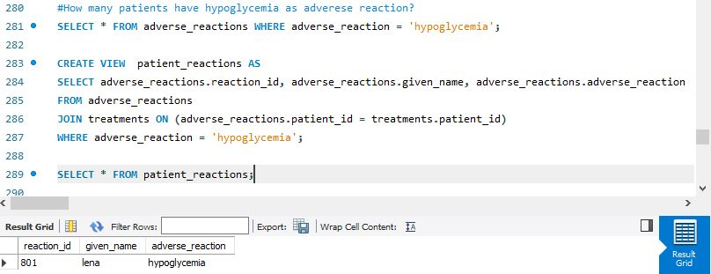

**How many Female patients are there?**

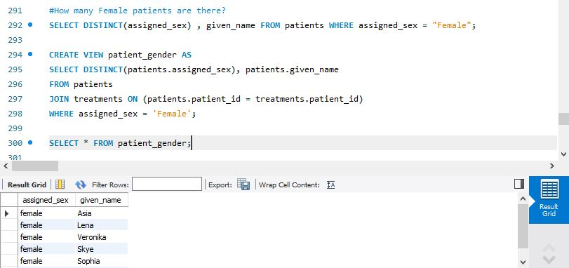

**Name the people who are treated with auralin?**

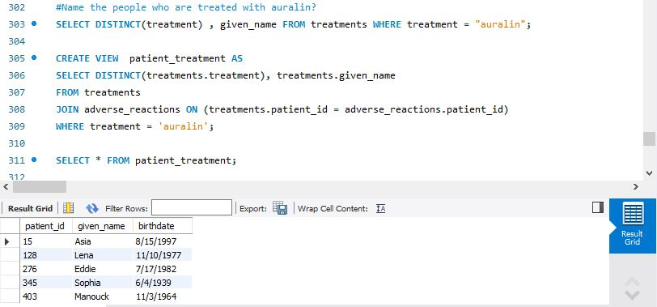

**Which patients birthdates are after 1/20/1934?**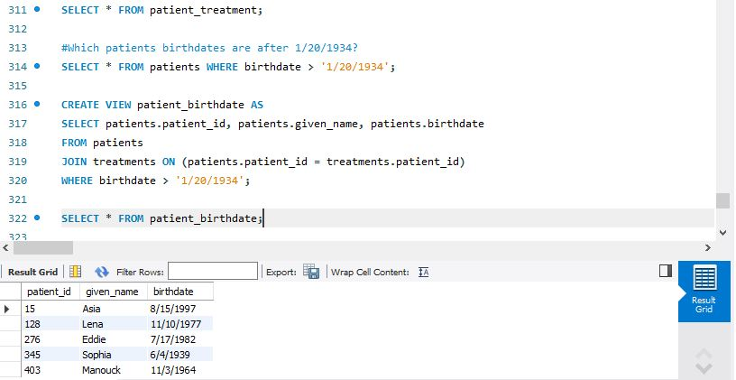

**How many Male doctors are there in the hospital?** 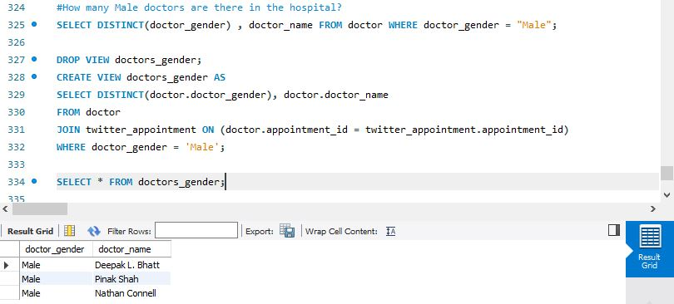

**#Which doctor is a Female Diagnostic radiology specialist?**